**Farming Around the World**

How does it impact agriculture?

How does it impact agriculture?

How does it impact agriculture?

How does it impact agriculture?

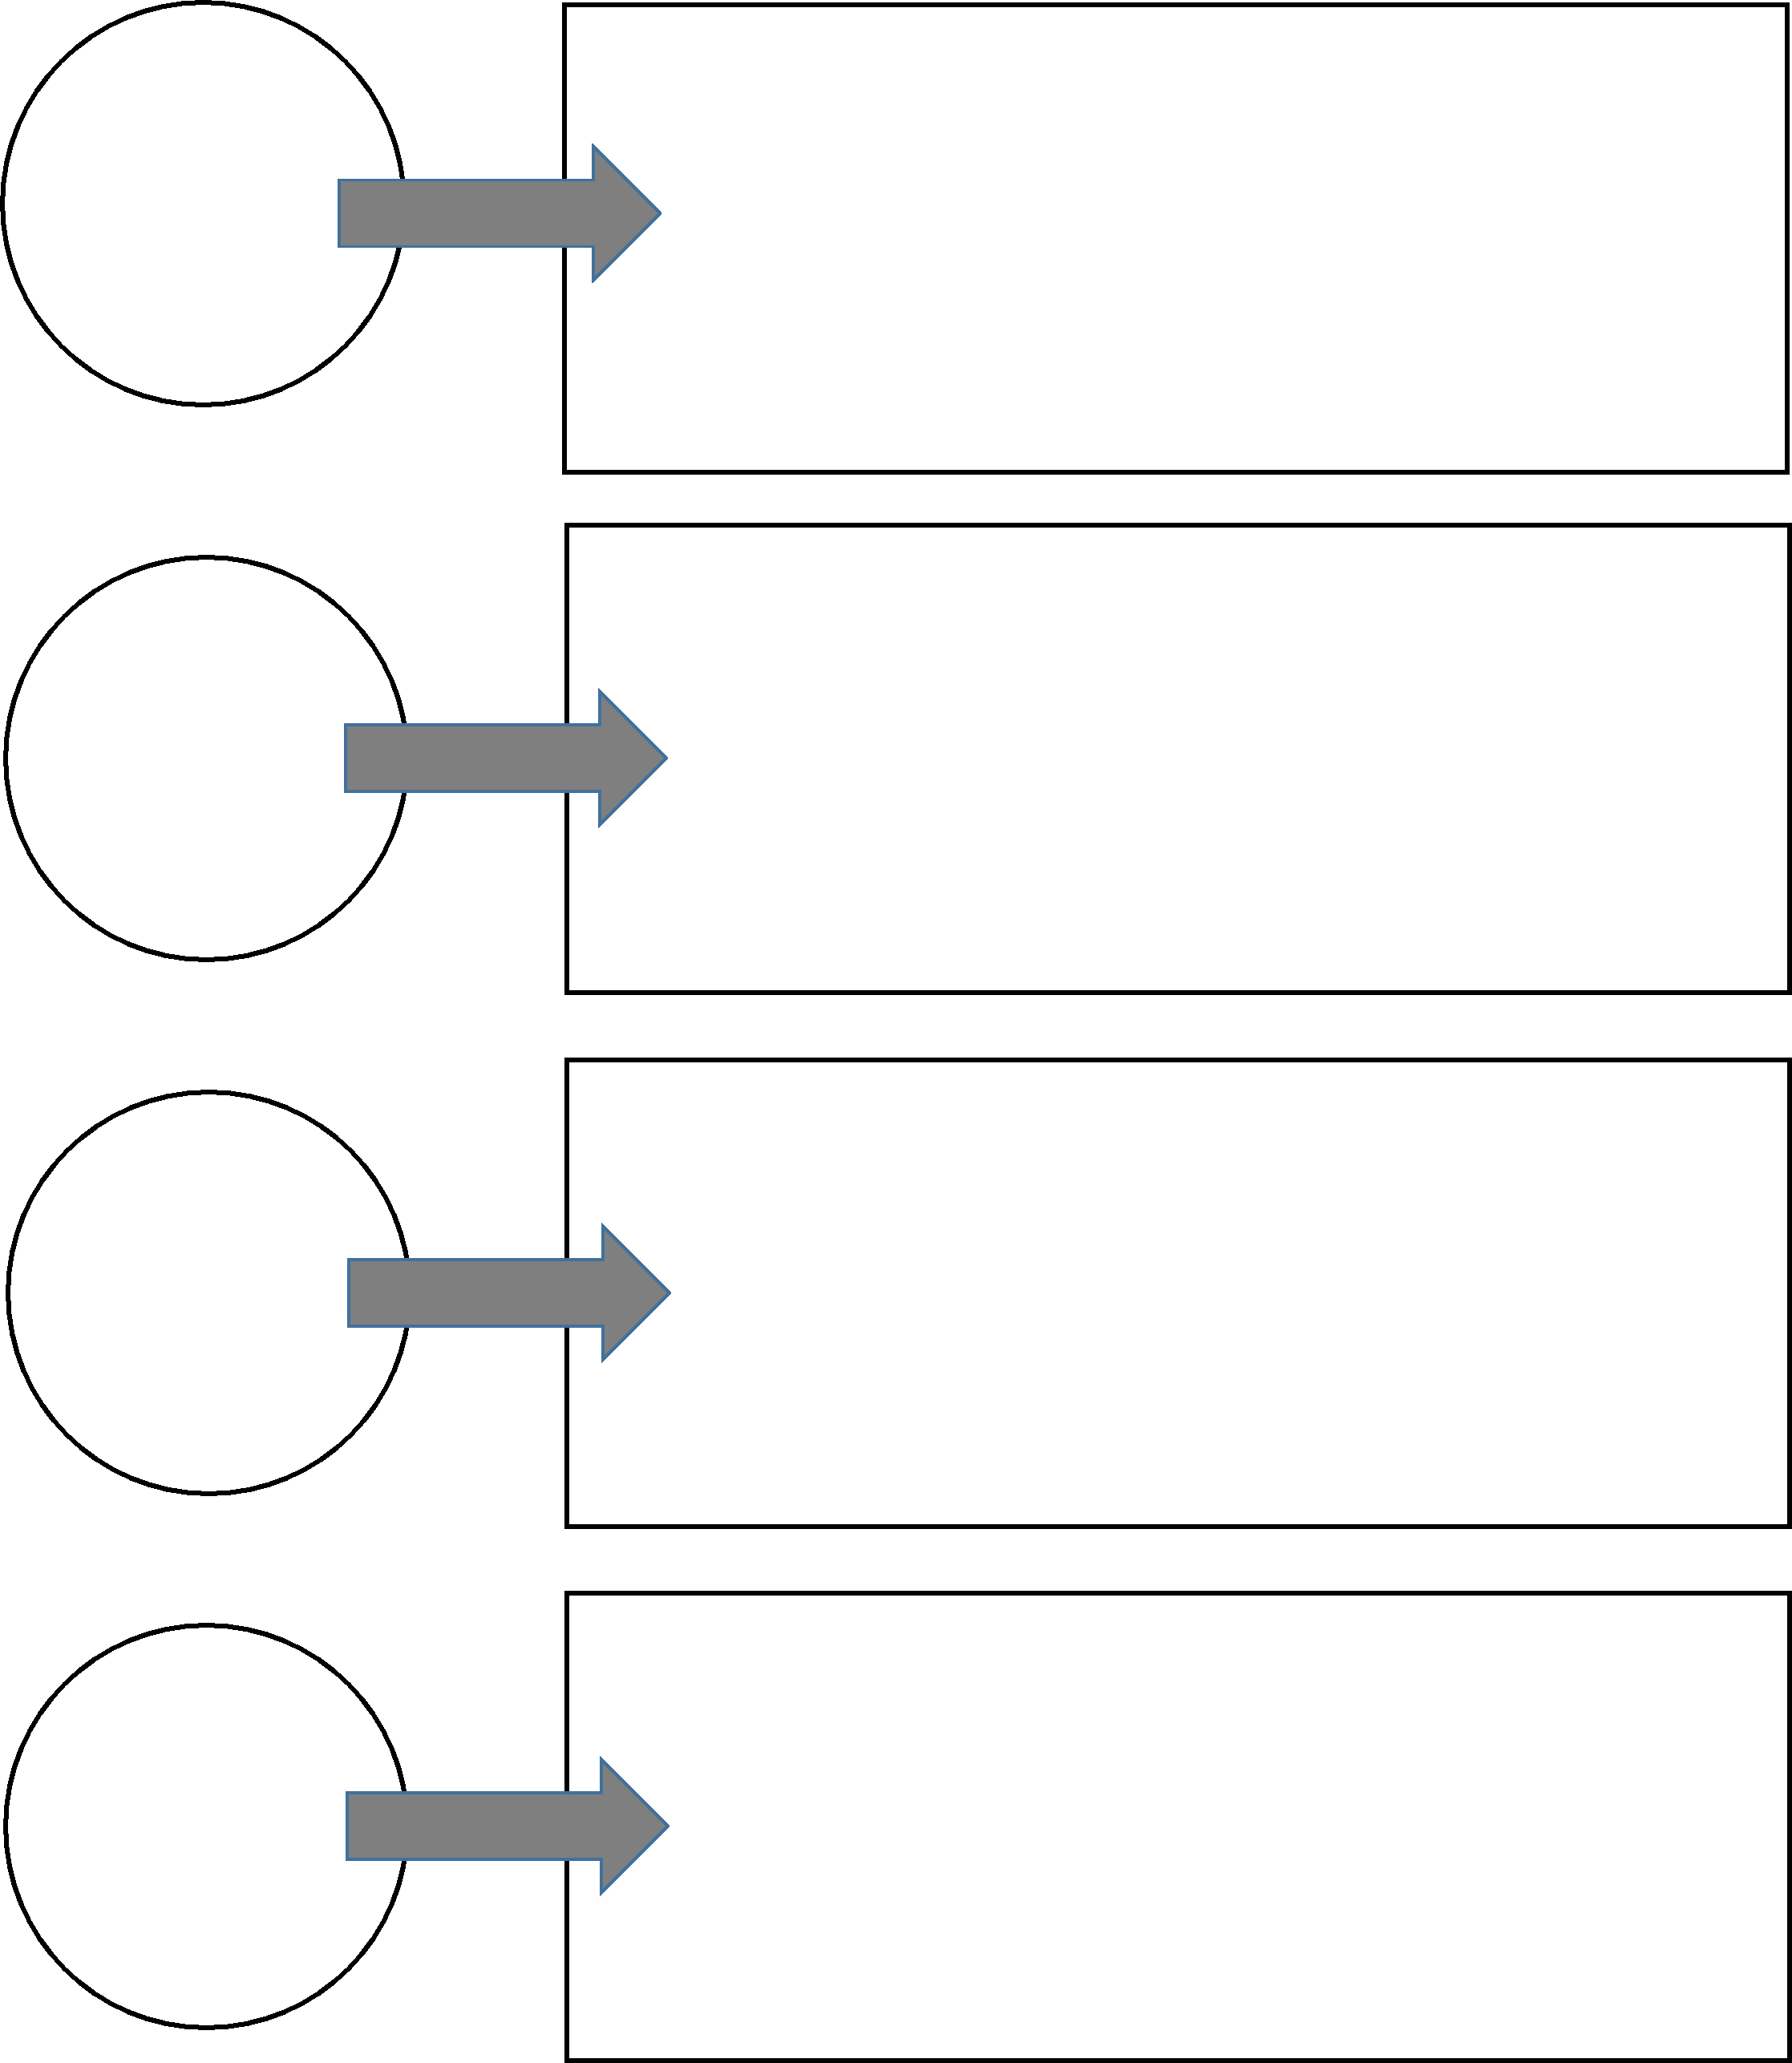

Climate

How food production is impacted

How food production is impacted

How food production is impacted

How food production is impacted